2.3 Authentication & Session Weakness Analysis

Name: Aisha Aslam

Position: Cybersecurity Intern

Organization: Skillset Go EduTech

Offer ID: SSG/REG/B1/0166

Environment: OWASP Juice Shop – Controlled Legal Practice Environment
Objective: Analyze authentication, session management, and input-validation weaknesses observed during the authorized practice-environment testing. This matches the Week 2 Task 2.3 requirement.

1. Authentication Weakness
The login functionality was tested using a SQL injection payload. The application accepted the crafted input and authentication was bypassed, demonstrating inadequate input handling in the authentication process.

2. Input-Validation Weakness
The search functionality was tested with an XSS payload. The application executed the injected content and displayed an alert, demonstrating insufficient handling of user-supplied input.

3. Session Management
After authentication, Chrome Developer Tools were used to inspect Local Storage. An authentication-related token was present in the Juice Shop domain's Local Storage. Browser-accessible token storage can increase exposure if malicious JavaScript executes in the same application context.
Evidence: The Local Storage screenshot was captured during testing. The token value has been redacted for security.
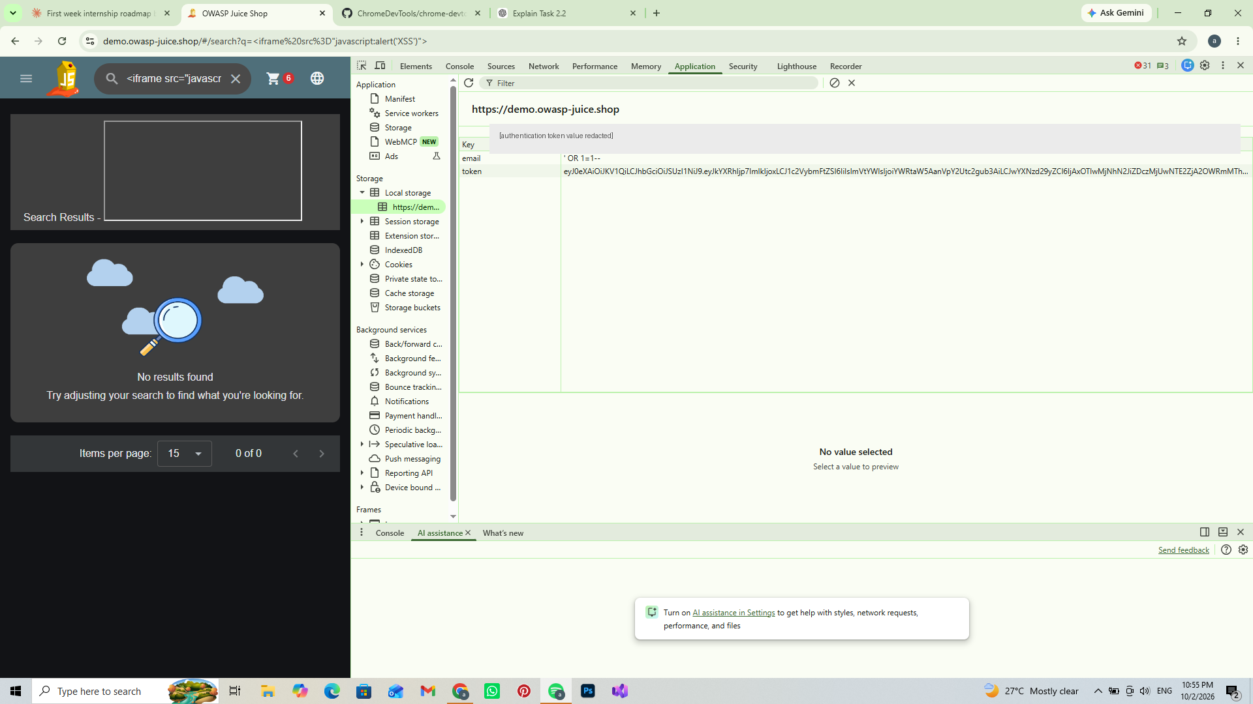
Figure 1 – Local Storage showing the authentication token key (value redacted)

4. Potential Impact
These weaknesses could contribute to authentication bypass, script execution, and potentially session compromise if an authentication token becomes accessible to malicious script.

5. Recommendations
- Use parameterized queries / prepared statements.
- Perform strong server-side input validation.
- Apply proper output encoding to prevent XSS.
- Use secure session-management practices.
- Protect authentication tokens from unnecessary client-side exposure.

6. Evidence Reference
The analysis is supported by the authentication-test and XSS-test screenshots captured during Task 2.2, plus the redacted Local Storage screenshot included above. The actual token value is not included.

Conclusion
The assessment demonstrated weaknesses in authentication, input validation, and session-management exposure within the controlled OWASP Juice Shop environment. The analysis highlights the need for secure input processing, parameterized database queries, output encoding, and appropriate session-management controls.

